# CS 255 System Design Document Template

This template lays out all the different sections that you need to complete for Project Two. Each section has guidance to prompt your thinking. You will need to continually reference the interview transcript as you work to make sure that you are addressing your client’s needs. There is no required length for the final document. Instead the goal is to complete each section based on what your client’s needs are. Remove this note when you are finished, and replace all bracketed text with the relevant information.

## UML Diagrams

### UML Use Case Diagram

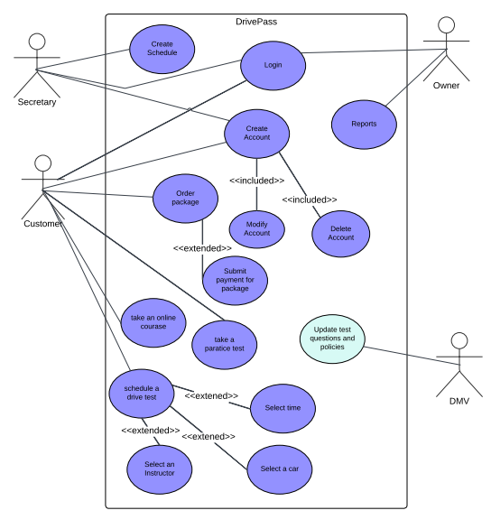

### UML Activity Diagrams

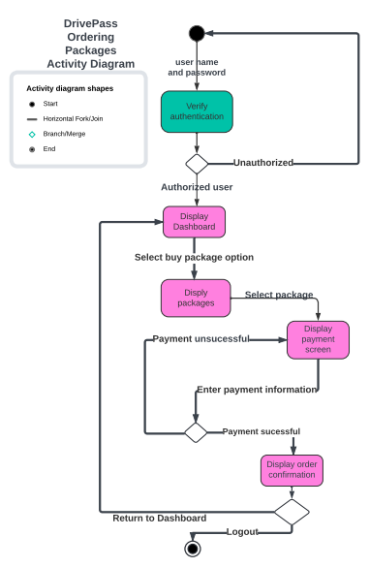

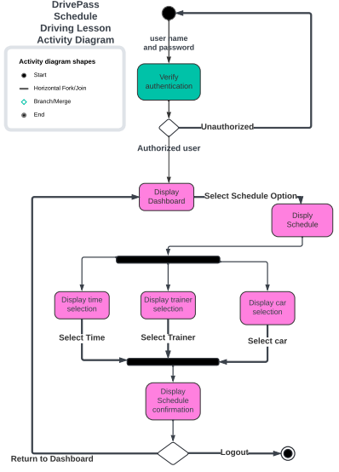

### UML Sequence Diagram

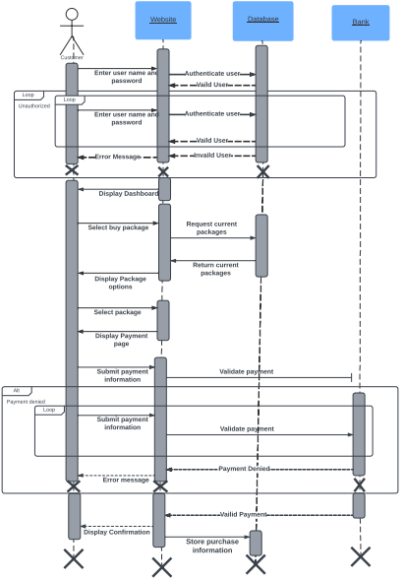

### UML Class Diagram

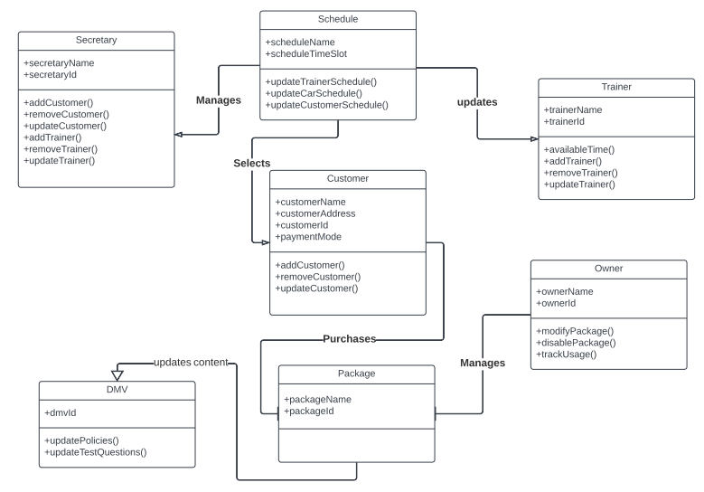

## Technical Requirements

Client requires Mobile access and PC access to the system. The mobile technical requirement includes any mobile phone or tablet which has access to the internet, either by WiFi or cellular internet is acceptable. The mobile devices need to run on IOS or Android each environment has to be the latest version or with in the last two previous versions. The PC includes all of it’s hardware in the tower, power cords, a keyboard, a mouse, and a screen. The PC must run on MacOS or Windows, each environment has to be the latest version or with in the last two previous versions.

The client requires a cloud based server.